LAB REPORT

CSE 1204

Digital Logic Design

***Khulna University of Engineering and Technology***

***Computer Science and Engineering***

|  |  |
| --- | --- |
| ***Name*** | ***: Doniel Tripura*** |
| ***Roll*** | ***: 1907121*** |
| ***Section*** | ***: B*** |
| ***Semester*** | ***: 2nd Semester*** |
| ***Experiment No*** | ***: 01*** |
| ***Experiment Name*** | ***: Logic Gates*** |

**EXPERIMENT: 1 LOGIC GATES**

**AIM:**

To study and verify the truth table of logic gates

**LEARNING OBJECTIVE:**

• Identify various ICs and their specification.

**COMPONENTS REQUIRED:**

• Logic gates (IC) trainer kit.

• Connecting patch chords.

• IC 7400, IC 7408, IC 7432, IC 7406, IC 7402, IC 7404, IC 7486

**THEORY:** The basic logic gates are the building blocks of more complex logic circuits. These logic gates perform the basic Boolean functions, such as AND, OR, NAND, NOR, Inversion, Exclusive-OR, Exclusive-NOR. Fig. below shows the circuit symbol, Boolean function, and truth. It is seen from the Fig that each gate has one or two binary inputs, A and B, and one binary output, C. The small circle on the output of the circuit symbols designates the logic complement. The AND, OR, NAND, and NOR gates can be extended to have more than two inputs. A gate can be extended to have multiple inputs if the binary operation it represents is commutative and associative. These basic logic gates are implemented as small-scale integrated circuits (SSICs) or as part of more complex medium scale (MSI) or very large-scale (VLSI) integrated circuits. Digital IC gates are classified not only by their logic operation, but also the specific logic-circuit family to which they belong. Each logic family has its own basic electronic circuit upon which more complex digital circuits and functions are developed. The following logic families are the most frequently used.

**TTL** Transistor-transistor logic

**ECL** Emitter-coupled logic

**MOS** Metal-oxide semiconductor

**CMOS** Complementary metal-oxide semiconductor

TTL and ECL are based upon bipolar transistors. TTL has a well established popularity among logic families. ECL is used only in systems requiring high-speed operation. MOS and CMOS, are based on field effect transistors. They are widely used in large scale integrated circuits because of their high component density and relatively low power consumption. CMOS logic consumes far less power than MOS logic. There are various commercial integrated circuit chips available.

TTL ICs are usually distinguished by numerical designation as the 5400 and 7400 series.

**NAND GATE (IC 7400)**

|  |  |  |
| --- | --- | --- |
| **INPUT** | | **OUTPUT** |
| A | B | C=~(AB) |
| 0 | 0 | 1 |
| 0 | 1 | 1 |
| 1 | 0 | 1 |
| 1 | 1 | 0 |

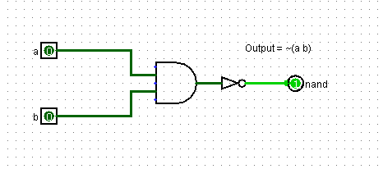

**Fig: NAND Gate**

**TRUTH TABLE**

**NOR GATE (IC 7402)**

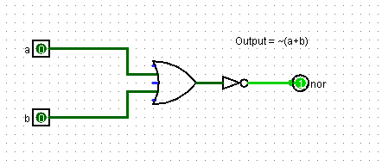

**Fig: NOR Gate**

**TRUTH TABLE**

|  |  |  |
| --- | --- | --- |
| **INPUT** | | **OUTPUT** |
| A | B | C=~(A+B) |
| 0 | 0 | 1 |
| 0 | 1 | 0 |
| 1 | 0 | 0 |
| 1 | 1 | 0 |

**AND GATE(IC 7408)**

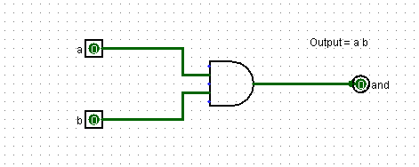

Fig: AND Gate

**TRUTH TABLE**

|  |  |  |
| --- | --- | --- |
| INPUT | | OUTPUT |
| A | B | C = AB |
| 0 | 0 | 0 |
| 0 | 1 | 0 |
| 1 | 0 | 0 |
| 1 | 1 | 1 |

**OR GATE (IC 7432)**

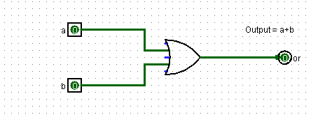

Fig: OR Gate

**TRUTH TABLE**

|  |  |  |
| --- | --- | --- |
| INPUT | | OUTPUT |
| A | B | C=A+B |
| 0 | 0 | 0 |
| 0 | 1 | 1 |
| 1 | 0 | 1 |
| 1 | 1 | 1 |

**NOT GATE (IC 7404)**

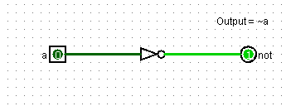

Fig: NOT Gate

**TRUTH TABLE**

|  |  |
| --- | --- |
| **INTPUT** | **OUTPUT** |
| A | C=~A |
| 0 | 1 |
| 1 | 0 |

**EX-OR GATE**

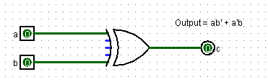

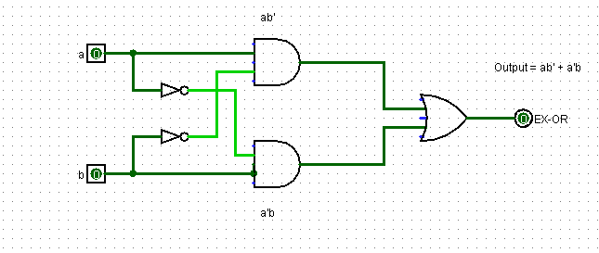

**Fig: EX-OR Gate**

**TRUTH TABLE**

|  |  |  |
| --- | --- | --- |
| INPUT | | OUTPUT |
| A | B | C= AB’ + A’B |
| 0 | 0 | 0 |
| 0 | 1 | 1 |
| 1 | 0 | 1 |
| 1 | 1 | 0 |

**VIVA QUESTIONS:**

**1. Why NAND & NOR gates are called universal gates?**

**Ans:**

We can creat any other types of gate for examle OR, AND, NOT using NAND and NOR gate. That’s why they are called universal gates.

**2. Realize the EX – OR gates using minimum number of NAND gates.**

**Ans:**

We know that,

Output for X-OR gate,

**Y=AB’ + A’B**

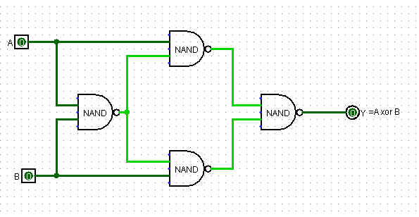

**Fig: Realizing the EX–OR gates using minimum number of NAND gates.**

**3. Give the truth table for EX-NOR and realize using NAND gates?**

**Ans:**

**TRUTH TABLE of EX-NOR Gate:**

|  |  |  |
| --- | --- | --- |
| **INPUT** | | **OUTPUT** |
| A | B | C= A x-nor B |
| 0 | 0 | 1 |
| 0 | 1 | 0 |
| 1 | 0 | 0 |
| 1 | 1 | 1 |

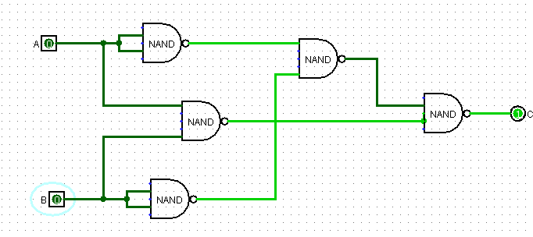

**Fig: Realizing the EX-NOR gate using NAND gates.**

**4. What are the logic low and High levels of TTL IC’s and CMOS IC’s?**

**Ans:** A TTL input signal 0 V and 0.8 V is defined as ‘low’ and 0.8 V to 2.0 V is defined as ‘high’.

A CMOS input signal 0 V and 1.5 V is defined as ‘low’ and 3.5 V and 5.0 V is defined as ‘high’.

**5. Compare TTL logic family with CMOS family?**

**Ans:**

Comparing TTL and CMOS family-

|  |  |
| --- | --- |
| **TTL** | **CMOS** |
| Consume high power. | Consume low power. |
| Bigger than CMOS. | Smaller than TTL. |
| Propagation delay isn’t so small. | Propagation delay is small. |
| Transmission slow. | Transmission fast. |

**6. Which logic family is fastest and which has low power dissipation?**

**Ans:**

**ECL** logic family is fastest and **MOS** logic family has low power dissipation.